# The 124th National Black Business Conference: Bridging Legacy and Innovation in Atlanta

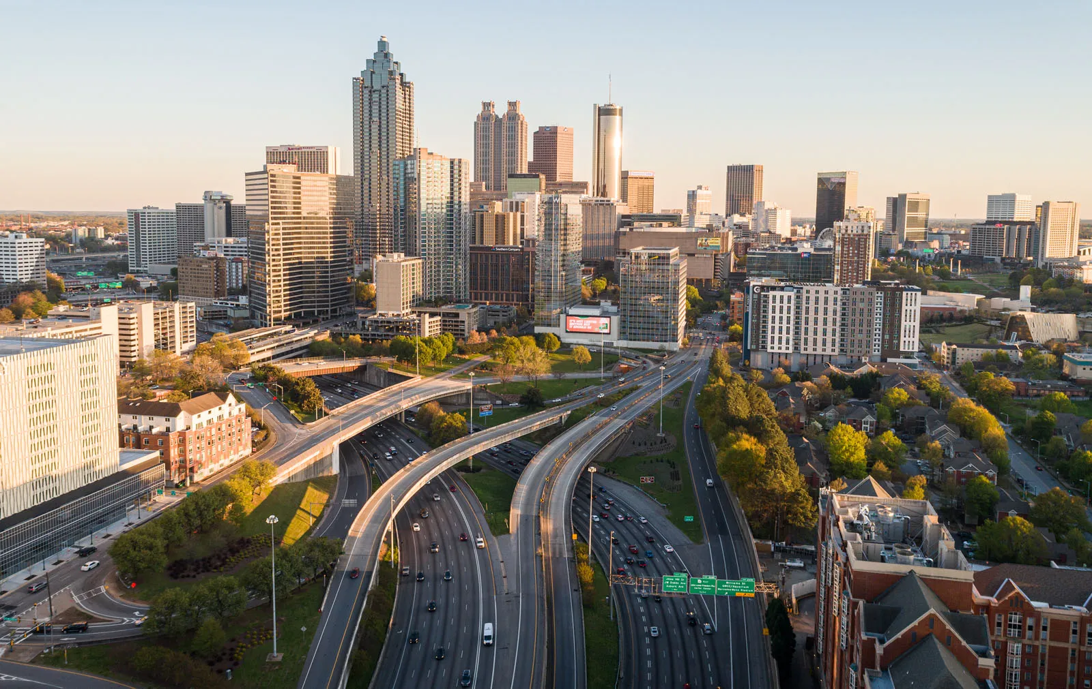

Image via: [Brittanica](https://cdn.britannica.com/22/255622-050-2FC36DF1/downtown-Atlanta-Georgia.jpg)

**Meta Description:** *Join us at the 124th National Black Business Conference in Atlanta to celebrate the legacy and drive innovation among black entrepreneurs. Network, learn, and grow with industry leaders.*

As the 124th National Black Business Conference returns to Atlanta, it marks not just another annual gathering, but a vibrant celebration of legacy, innovation, and the continuous growth of the black business community. Hosted by the National Business League, this event is set to empower entrepreneurs and business leaders with opportunities for networking, learning, and collaboration.

#### **Celebrating a Rich Legacy**

The National Black Business Conference holds a prestigious place in history as a beacon for black entrepreneurship and economic empowerment. Over the decades, this event has been instrumental in setting the stage for dialogue, partnership, and the fostering of business opportunities within the black community. Its return to Atlanta—a city known for its dynamic business environment and rich cultural history—is especially significant. This convergence serves as a reminder of the city’s role as a hub for black business excellence and innovation.

#### **A Platform for Modern Business Innovations**

This year’s conference theme, "We Are Together," resonates through its agenda, which is designed to address the modern challenges and opportunities facing today’s black businesses. Innovations in technology, strategies for scaling businesses, and insights into consumer trends are among the key topics. The conference also provides a unique platform for black entrepreneurs to showcase their businesses, gain visibility, and attract investment.

#### **Empowering Through Knowledge and Networking**

The 124th edition of the conference offers more than just speeches and panel discussions. It is structured to provide tangible value through workshops, mentorship sessions, and roundtable discussions. These sessions are tailored to equip attendees with practical skills and up-to-date knowledge on various aspects of business operations, from digital marketing strategies to financial management and beyond.

Networking opportunities abound, with spaces designed for entrepreneurs to connect with potential mentors, collaborators, and investors. This environment encourages the sharing of ideas and experiences, fostering partnerships that could lead to innovative business ventures or collaborative projects.

#### **Spotlight on Leadership and Visionaries**

Keynote speakers at the conference include industry leaders who have made significant impacts in their fields. Their stories are not just inspiring but also provide actionable insights that attendees can apply in their own entrepreneurial journeys. Among the luminaries, Dr. Ken Harris stands out as a figure of immense influence, whose insights into economic development and community empowerment have been pivotal.

#### **Supporting the Next Generation**

A special focus of this year’s conference is on the next generation of black entrepreneurs. Special sessions are dedicated to young business minds, focusing on equipping them with the skills and knowledge necessary to navigate the evolving business landscape. These sessions address topics like innovation in technology, the importance of sustainable practices, and the impact of global market trends on local businesses.

#### **Conclusion: A Beacon for the Future**

As the 124th National Black Business Conference gears up to open its doors in Atlanta, it promises to be more than just an event. It is a catalyst for growth, a source of inspiration, and a bridge between the rich legacy of the past and the innovative spirit that drives the future of black business in America. This conference is not just an event to attend; it’s an experience to be part of, a community to engage with, and a valuable resource for any black entrepreneur looking to make their mark in the business world.

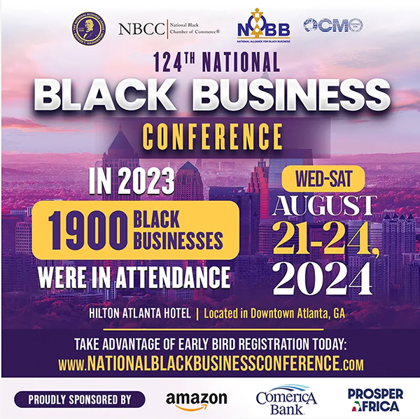National [Business](https://stlargusnews.com/marketing-tips-for-atlanta-businesses/) League Returns to [Atlanta](https://stlargusnews.com/digital-networks-in-atlanta-and-their-growing-influence/) Hilton for its 124th Conference

**Join the 124th National** [**Black**](https://stlargusnews.com/black-dinner-party-guests-of-prominent-ny-doctor-hosed-by-white-neighbor/) **Business Conference in Atlanta and network with** [**entrepreneurs**](https://stlargusnews.com/how-a-st-louis-nonprofit-empowers-entrepreneurs-and-shapes-the-citys-future/)**, collaborate with business leaders, and** [**empower**](https://stlargusnews.com/dear-lou-ameren/) **your business.**

[**Register Today.**](https://bit.ly/2024nblconference)

#NBBC124, #BlackBusiness, #AtlantaConference